WSCS – ASPS Council Report – 2019 ASPS meeting at LaTrobe
About the Website & Communications Sub-Committee (WSCS)
Goal: disseminate information related to ASPS and plant biology among the society members and general public and promote ASPS.
Current Members:
- Janet Wheeler (Webmaster and email master)
- Georgia Koerber (Phytogen master)
- William Salter (Social media master)
- Beth Loveys (Education master)
- Caitlin Byrt (Chair)
Past members: Gonzalo Estavillo, Chris Cazzonelli, Tina Offler. WSCS was established following the 2014 AGM.

Member database – 275 current members and 875 past members
Membership type | Number | Comments
Ordinary | 127 | 35 x 1 year  52 x 2 year  40 x 4 year
Student | 118 | 108 x 2 year (+8 followed from 4 year membership)  2 x 4 year
Retired | 7
Corresponding | 12
Life | 7
Gratis | 4
Sustaining | 0
Total | 275 | 245 financial

Details of Executive Committee and Reps on the webpage have already been updated by Janet.
Googledocs – Need to review whether there is a better way to retain WSCS records and documents (linked with or independent from Exec records?)
Awardee information – has already been updated for 2019 by Janet.
Need to check what happened in relation to the ‘consolidation of awards’ item in previous minutes
Phytogen
In the past year, there has been a monthly newsletter, the Phytogen blog. Most award recipients wrote reports and these became valuable contributions. Email addresses not working was the only reason why a few were missed, otherwise responses were very positive in their desire to contribute.
The Phytogen blog is a lovely way to archive activity of the society.
To enhance Phytogen, we would like to suggest guest editors/articles for some months, such as by students, researchers, discipline representatives and state chapters.
Open to format of the newsletter, whether it bothers people having to scroll down a lot or if it would be desirable to have links to read the full article. The monthly emails to members linked with the GPC bulletin and flow through to twitter and facebook serves to get our activity out there. Janet, if you think, it would be interesting to have a look at wordpress, support, stats, to see traffic. That way I can tell if some months were more popular than others.
Calendar – we need to update it now that our meeting time has moved and everything has shifted around.
Social media
In the past year, we have strategically increased the presence of ASPS on social media (Twitter and Facebook). We decided it best, based on the demographics of each platform, to use Twitter to promote Australian plant science research and increase the exposure of ASPS in the global plant science community, and to use Facebook to communicate more with the wider community and to disseminate educational and outreach resources. This strategy has worked well, with our following increasing substantially on both platforms over the past twelve months.

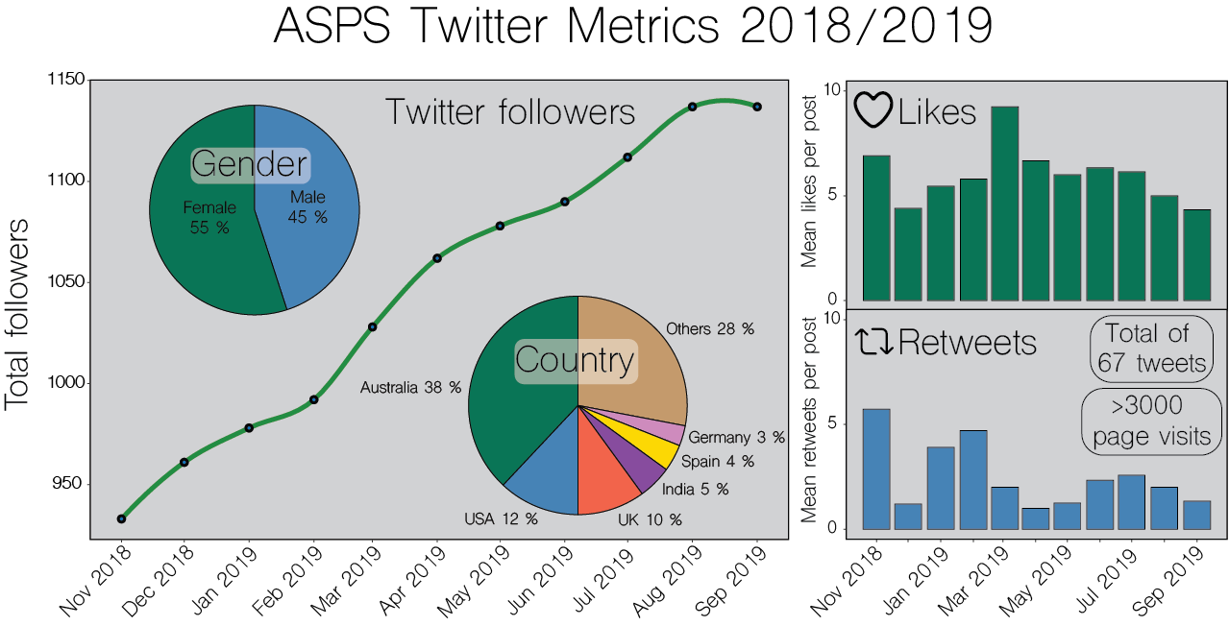
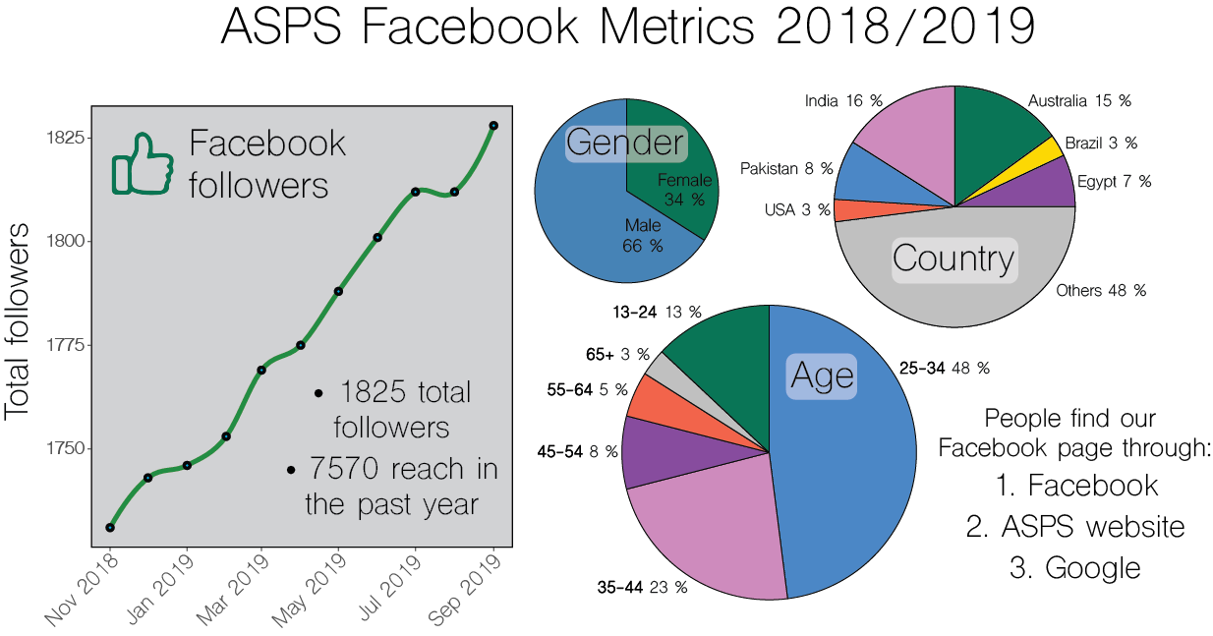

We have realised the importance of social media for networking within the plant science community and propose that a role for new student reps could be assisting in the management of the ASPS social media streams, under the guidance of WCSC members. This will offer them the opportunity to enhance their science communication skills and further boost the society’s presence on Twitter and Facebook.
We produced a guide to Twitter for plant scientists that was posted on the ASPS website earlier this year. This was designed to introduce those unfamiliar with Twitter a starter pack, with guidance on how to set up a profile and tips on the terminology and how to get the most out of the platform. We hope to update this periodically based on feedback from ASPS members.

Items on the list to review, revise or initiate
  - Science meets Parliament and conference funding – process?
  - ASPS promotion at University departmental seminar series (state reps)

Other matters
We have a new ASPS banner! Can be used at conferences or similar to promote ASPS. Please contact Georgia if you would like to use it.
The WSCS are happy to promote conferences, forward any relevant conference information to any committee member for promotion via social media or Phytogen.
A ‘no tweet’ symbol has been developed to be used if sensitive information or content is being presented; otherwise members are encouraged to share and promote work on social media. Please tag us @asps_ozplants
The Minister for Agriculture, Senator the Hon Bridget McKenzie, asked the Parliamentary Committee to inquire into and report on growing Australian agriculture to $100 billion by 2030. Several members of ASPS (Vanessa Melino, Tracey Cuin, Mike Haydon, Ronan Broad and Beth Loveys) made a submission to the inquiry on behalf of all members. In total 56 submissions were made to the inquiry.

