Membership ecology of the ASPS
Results of the online Survey

Sebastian Pfautsch (USyd) and Ulrike Mathesius (ANU)

The online survey was open to all members from 5 to 9 April. We asked members 4 questions regarding their age, gender, what their highest degree was and in which country they earned it. Lastly, we asked for up to 5 keywords that best describe the member’s work. On average, the participants spent just over 2.5 minutes to complete the survey.
We received 155 completed surveys, representing a response rate of approximately 16%. This estimate is based on the membership list from 16 March 2017, excluding double listings, tallying at 952 members. Of course, more responses would have been nice to have, but that’s possibly not a bad result for an anonymous online survey, given widespread survey fatigue, spam Email loads and general time constraints. The following results are extracted from these responses.
Slightly more men compared to women took part in the survey (82 males, 73 females). Age structure between male and female participants did not differ significantly (p = 0.063). However, male participants were on average 47 years of age, while the average age of female participants was 5 years less (42 years; Fig. 1). The youngest/oldest male and female were 24/81 and 23/76 years old, respectively.

Figure 1: Age by gender of the participating ASPS members. Error bars show ±1 SD.
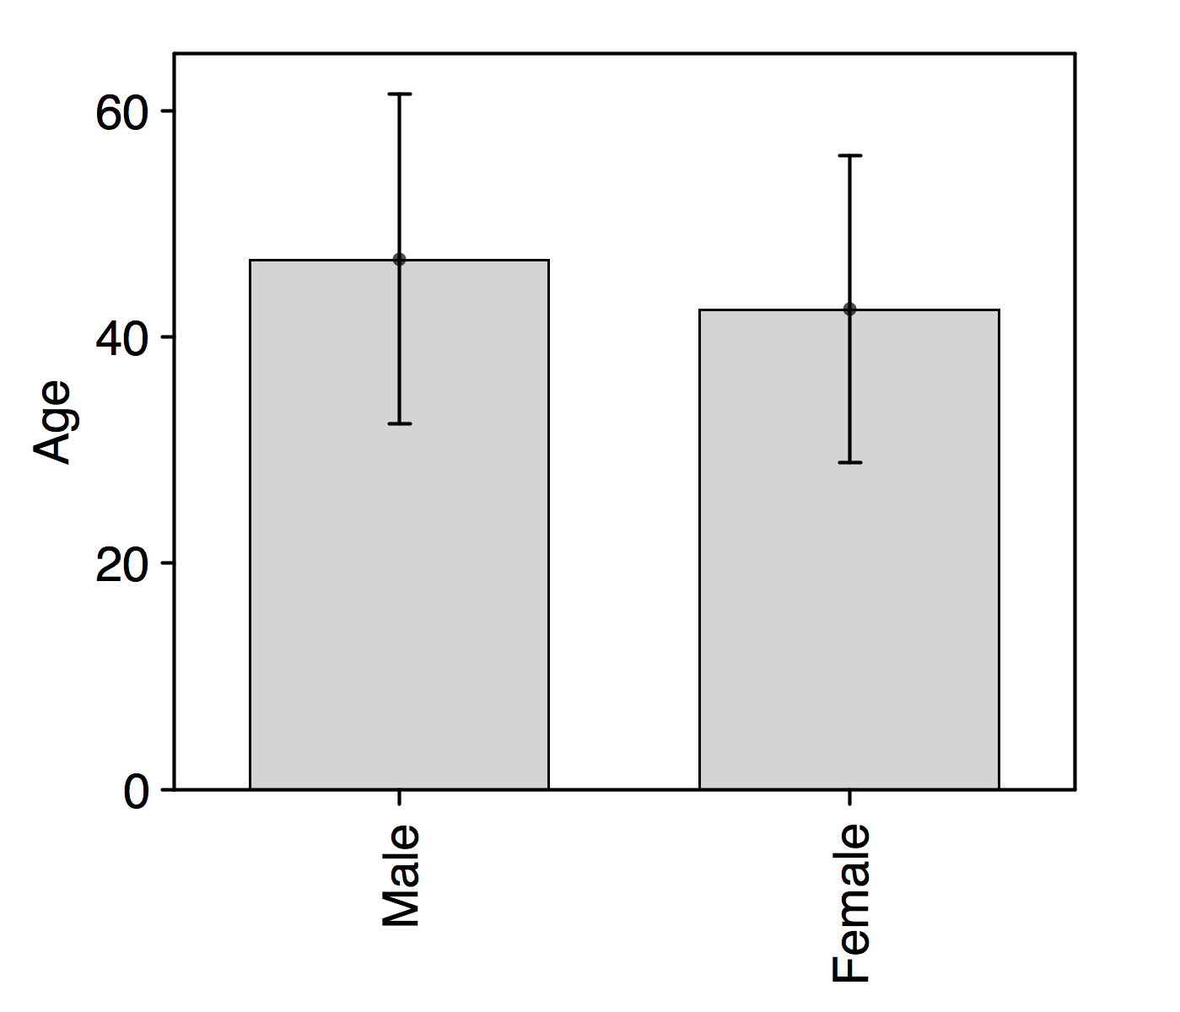
The distribution of age across survey participants was strongly and negatively skewed (Fig. 2). Both, male and female age distribution showed a clear ‘humped’ characteristic, indicating low numbers of members in the age bracket 55-60 years for males and 40-45 years for females.

Figure 2: Relative distribution of age among all survey participants separated by gender (male = blue; female = red).
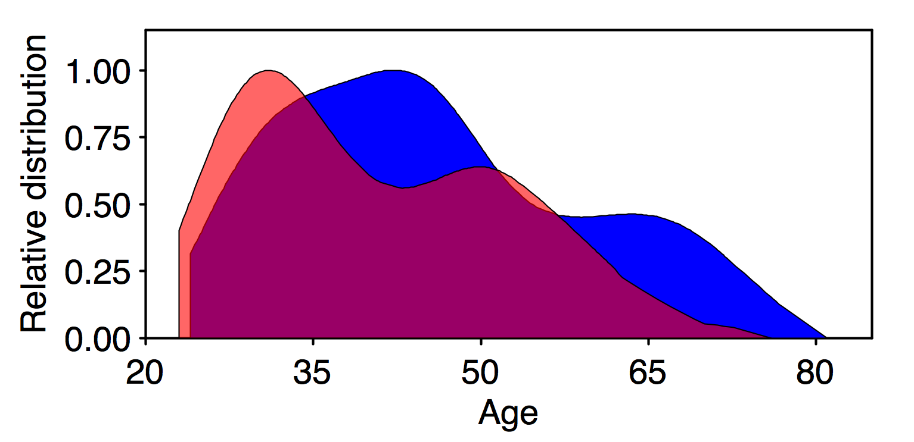
The number of degrees and their ranking differed among participants by gender. While the majority of ASPS members held PhD degrees (just under 80%), the proportion of male and female PhD holders differed. Of the 82 males, 73 held a PhD (90%), while 50 of 73 females (70%) held the same degree (Fig. 3). In contrast to PhD degrees, female participants held more than double the amount of Honors and Masters degrees compared to their male counterparts (21 female, 9 male). Only two bachelor students (one male, one female) participated.

Figure 3: Relative distribution of degrees held by participating ASPS members, separated by gender.
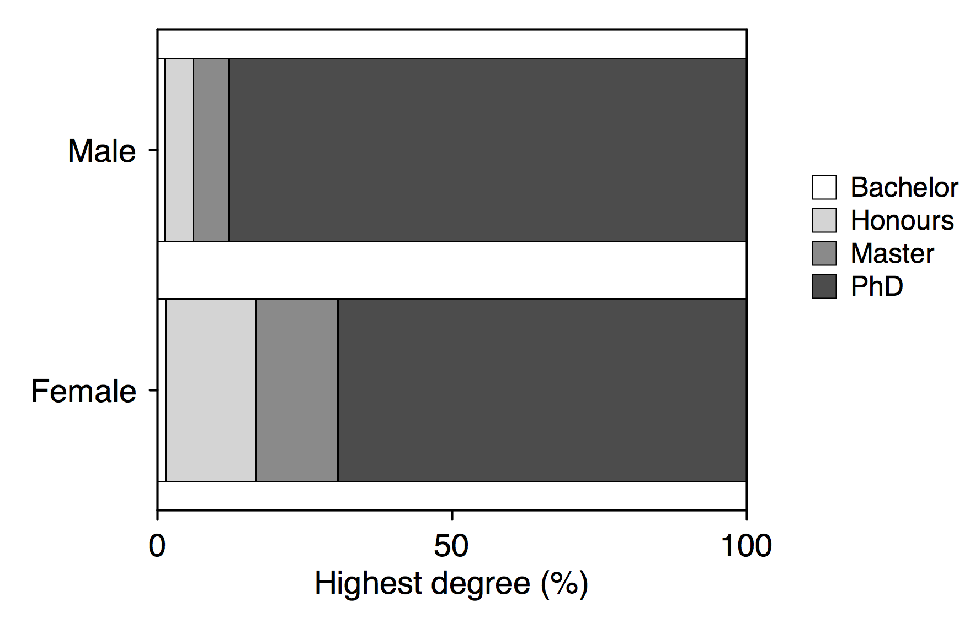

A positive relationship between age and type of degree was apparent if gender was ignored (Fig. 4a). When separated by gender, this trend prevailed, albeit some divergence occurred particularly in the group that held Masters degrees (Fig. 4b). Here females were on average 9 years older than their male counterparts. However, in all other categories age of male and females was very similar.

Figure 4: Age distribution across four categories of university degrees held by ASPS members. (a) Relationship between the type of degree and age; regression line shows best fit; coefficient of determination is shown. (b) The same relationship as in (a) separated by gender. Error bars show ±1 SD.
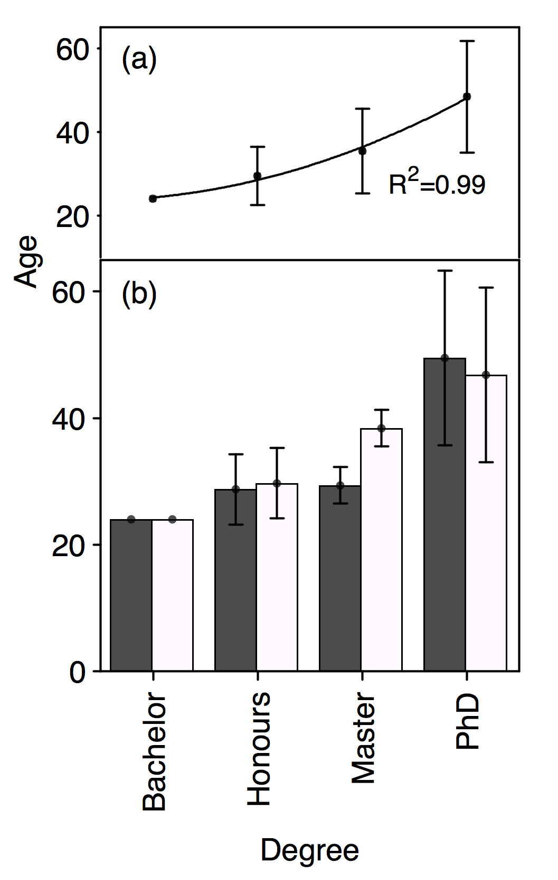
The participants received their degrees from a wide range of countries from around the world. As expected, Australia dominated the origin of degrees (107), followed by Europe (UK = 14, rest of Europe = 7) and North America (USA = 6, Canada = 4; Fig. 5).

Figure 5: Origin of member’s degrees by country.

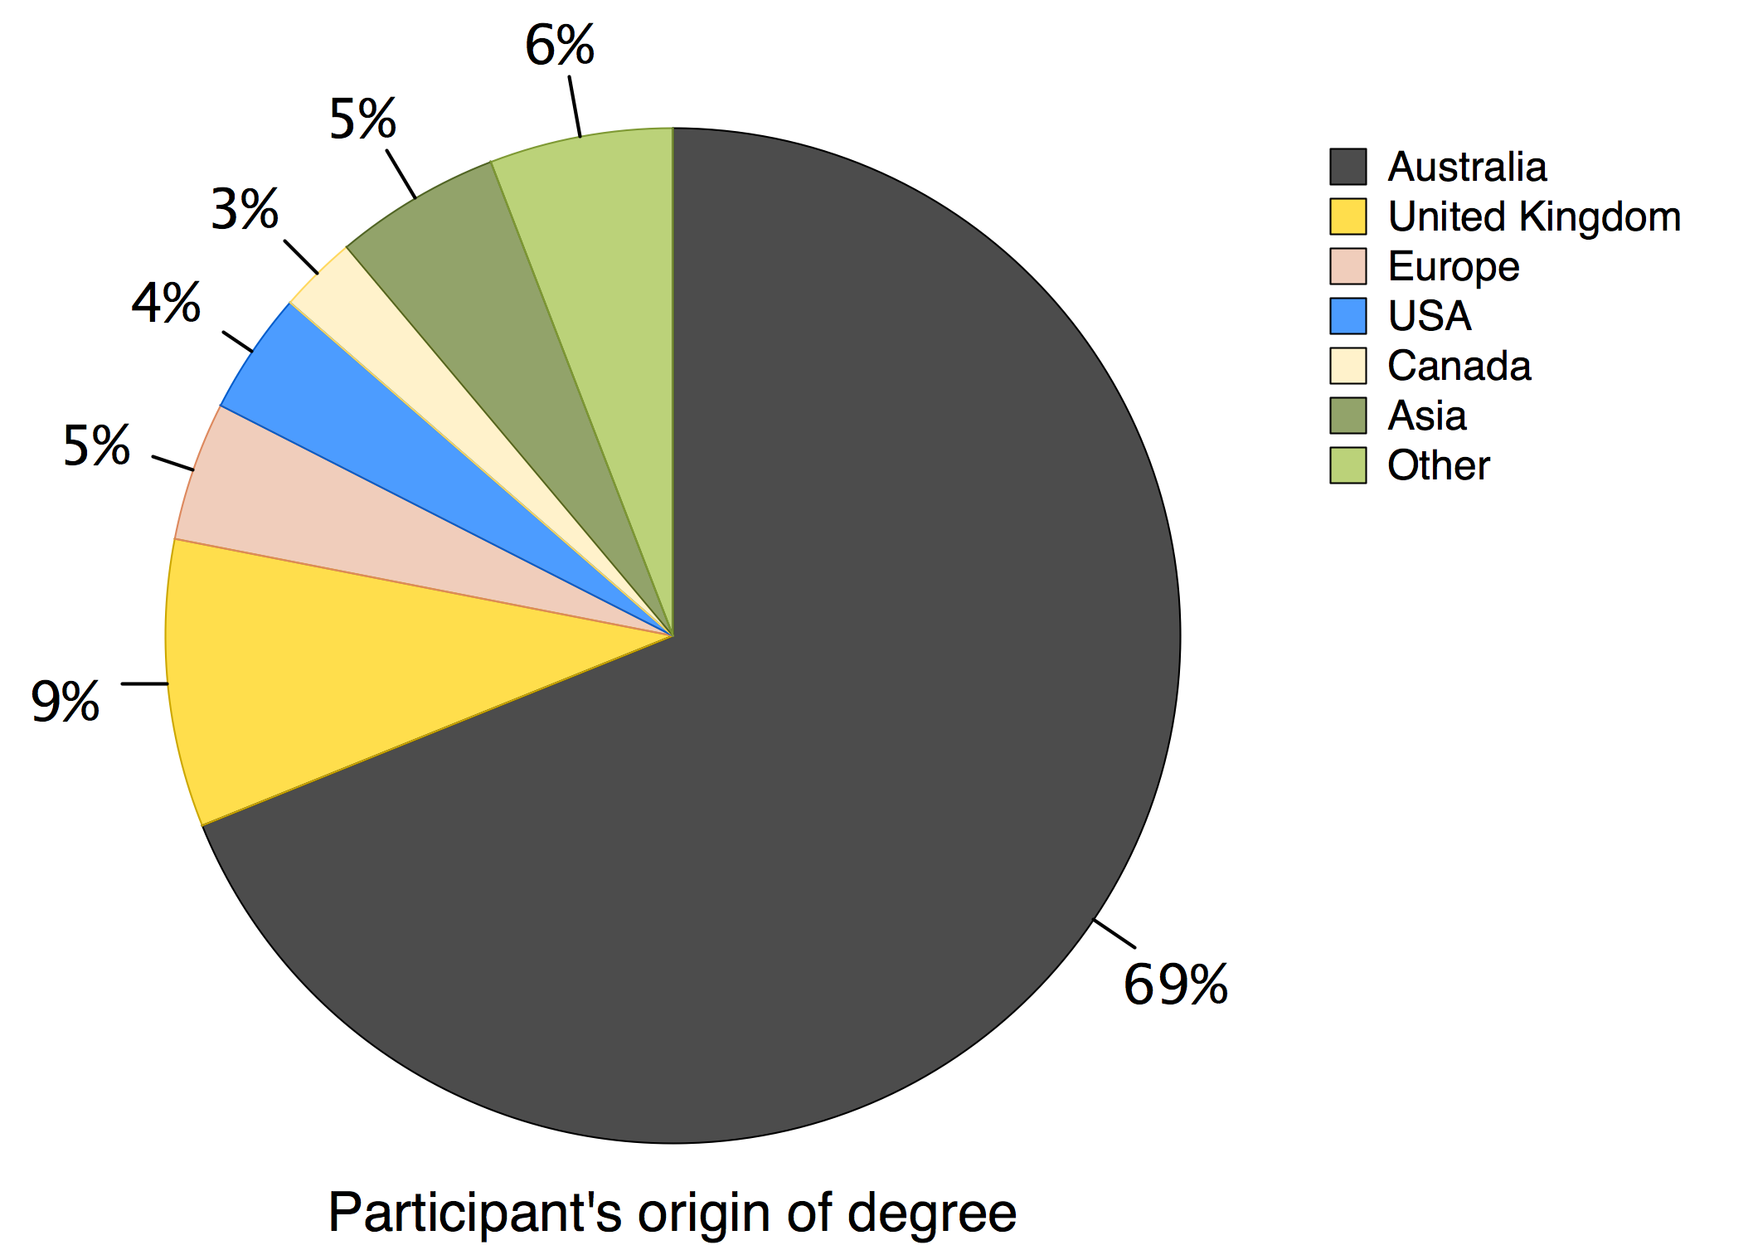

Overall, participating members held degrees granted from Universities in Australia, Austria, Brazil, Canada, Finland, France, Germany, India, Japan, Kenya, New Zealand, Pakistan, Russia, Sri Lanka, Sweden, Switzerland, UK, the United States and a couple of members that were not sure where they go their degrees from (3 ‘unknown’). How can that be? Anyway.
All Honors and the majority of PhD degrees of participating ASPS members were granted by Australian Universities (Fig. 6). This trend was only reversed in the category of Master degrees, where six of the nine participating members were female and all six from different countries, making this particular group the most diverse in regards of origin of their degree.

Figure 6: Degrees received by Australian universities versus degrees received from non-Australian universities.
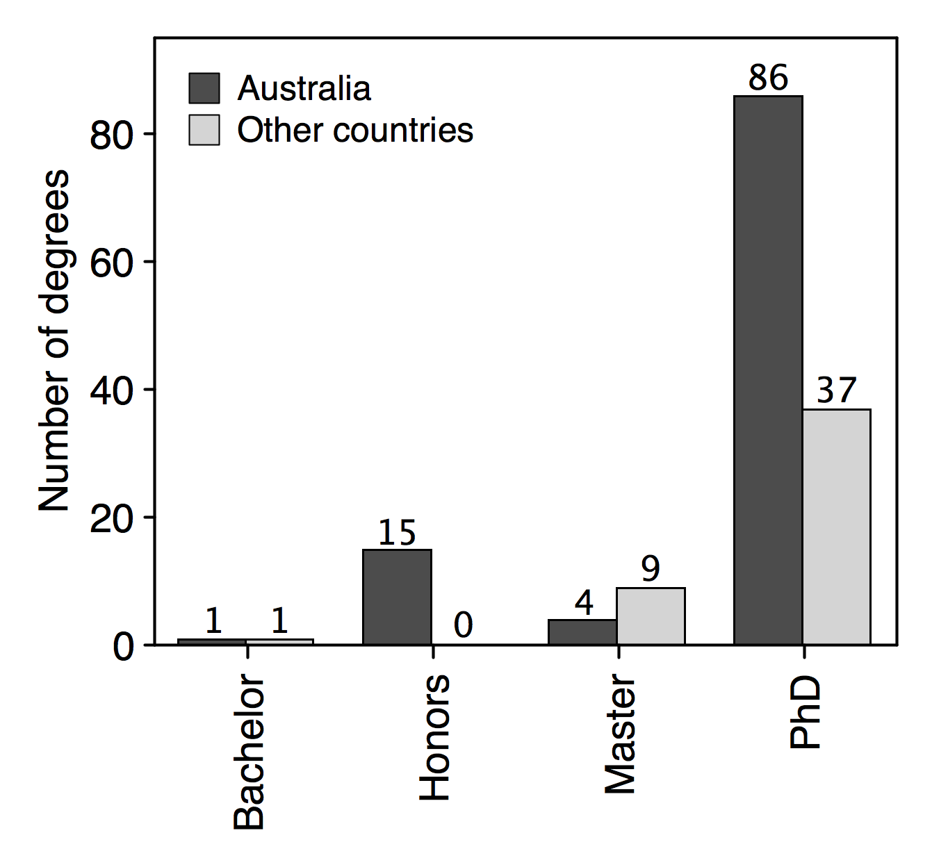
A total of 539 individual keywords were provided of which 436 had single nomination. To provide a more coherent list the keywords were unified (e.g. first letter always upper case), aggregated (e.g. Wheat moved into Crops, Salt Stress moved into Salinity, Abiotic Stresses and abiotic stress resistance all became Abiotic Stress) and simplified (e.g. Plant Biology became Biology, Plant Physiology became Physiology). This way the number of keywords was reduced to 228 of which only 137 mentioned once. It is worth mentioning that the categories Stress and Abiotic-Stress were kept separately. This decision was based on the ability to assign keywords like temperature stress to Abiotic-Stress. Yet, when only Stress was provided, no categorization was possible. Hence both categories of Stress and Abiotic-Stress were retained.
After streamlining the list of keywords, the most frequently used keyword was Physiology followed by Crop and Genetics (Table 1). Using some free online tools allowed production of a word-cloud that shows all terms that were cited at least 3 times (Fig. 7).

Table 1: Top 10 Keywords cited by 155 ASPS members when asked what best describes their work.

Ranking | Keyword | Citations
1 | Physiology | 40
2 | Crop | 36
3 | Genetics | 27
4 | Molecular Biology | 27
5 | Cell Biology | 19
6 | Abiotic Stress | 19
7 | Nutrition | 18
8 | Photosynthesis | 17
9 | Proteomics | 15
10 | Stress Physiology | 15

Key Findings & Suggestions
- Gender-Age-Degree Differences
It is great to see that the distribution of gender, age and degrees of participating ASPS members captures the ‘catching-up’ dynamics that female academics in natural science disciplines are exhibiting. Generally younger than their male counterparts, female ASPS members have a much greater potential to become future leaders in plant science due to the greater number of individuals that hold the relevant qualifications (Honors, Masters) for progressing towards PhD degrees.
The presented gender distribution is restricted by the low response rate of the survey. As an additional step, it may be worthwhile to compare the current with the entire membership, using the membership data base.

- Age Distribution
So far there is no trend towards over-aging of the ASPS, although young members (i.e. less than 30 years of age) are not well represented. This may be a reflection of the education system that produces postdocs that are at the end of their 20s or early 30s. At this time membership in a professional research society might not be seen as highly beneficial. With progression of ECR into more senior roles this perception appears to change. It thus might be of value to the age distribution of the ASPS to specifically encourage PhD students and postdocs to join the society. Here it would be important to clearly define the benefits of membership for these particular groups.
A more insightful analysis of the age distribution within ASPS members will be possible once our suggested changes in the online membership renewal process are implemented. To date, we only know the age of less than 20% of our members that participated in the survey.

- Australia-based
The majority of ASPS members have received their degrees from an Australian university. Yet, it becomes clear that there is a considerable cohort of members that join the society with degrees that were granted in many other countries. This may not only represent a reflection of the multi-cultural society in Australia, but may also indicate a social aspect of academic research: high degrees of personal mobility are required to find the right job at the right time in this globalized world.

- Focus on Plant Stress and Molecular Biology
Admittedly, the streamlining of the key word database can be optimised. Here we present a first attempt only. How do we deal with a large number of highly specialised terms that are only mentioned once? On the other hand, this long list also reflects the high level of specialisation amongst plant scientists in Australia, which is clearly a strength and worthy as marketing asset.

Figure 7: Word-cloud of key words that were cited at least 3 times by participants of the survey. Frequency of citations is indicated by font size and color.

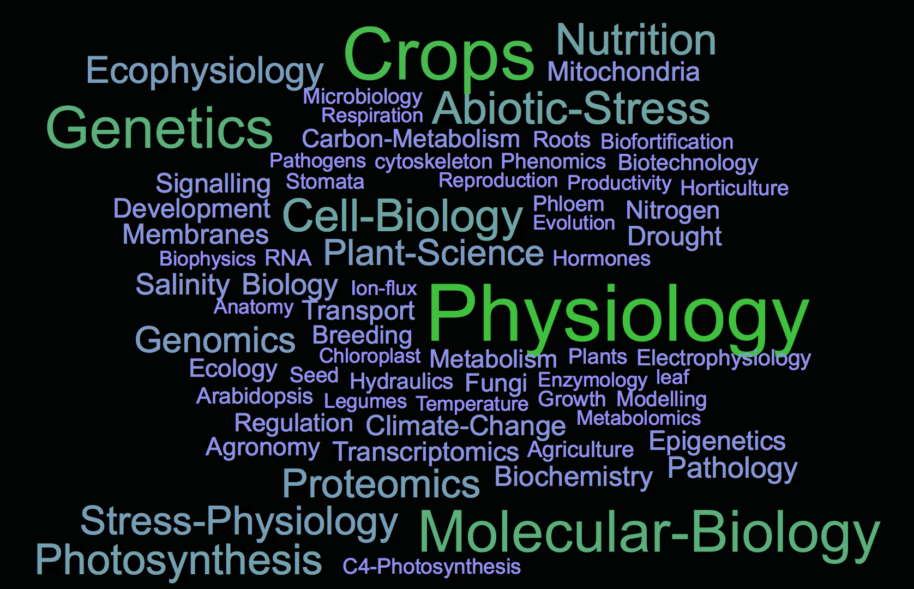

If a member provides Plants as a keyword, can it be used at all? Similarly, is Biology the same as Plant Biology? Several other examples may require further scrutiny.
It may not come as a surprise that key words related to wider molecular biology ranked overall on top (62 citations of Molecular Biology, Genomics and Genetics). What is remarkable, though, is the strong focus of our members to work on topics that involve plant stresses in one form or another (Abiotic Stress cited 18 times, Stress Physiology cited 14 times). Also, members of ASPS seem to have a strong connection to industry, given that the related categories are cited about 50-times (i.e. Crops, Breeding, Agriculture, Agronomy). In contrast, key words related to native ecosystems, species or processes therein are not very well represented. These and similar examinations for the – hopefully growing – keyword data base can be use strategically to motivate members to host specific sessions within the ComBio conference framework, or to propose specialised workshops and meetings hosted by the ASPS (e.g. Plant Stress Meeting, Progress in Plant Genetics Workshop, etc.).

