# Logo Description automatically generatedReport on Global Plant Council for ASPS Annual Meeting

November 2021

The GPC is a coalition of plant, crop, agricultural & environmental science organizations. There are currently 27 member organisations and a number of sponsor organisations including a number of journals and the American Society of Plant Biology (for various reasons). It was founded in 2009 and grown in status and range of activities.

The ASPS is one of the founding members and continues to be a core member. Ros Gleadow is the ASPS representative and is President of the GPC. Australian Elizabeth Nielson, representing the Scandinavia Society of Plant Physiologists, is the Chair, replacing Barry Pogson who was the ASPS rep and Chair for many years.

The aim of the GPC is to

* Promote plant science to address global challenges;
* Foster international collaborations, enable knowledge exchange and effective use of resources;
* Provide a forum to bring together all those involved in plant and crop research, training.

The Council is incorporated in Canada and governed by a Board of Directors, with representatives from each continent except Africa (currently Mexico, Canada, UK, Chile, Argentina, Denmark, India, China, Japan, Australia). The Chief communications officer, Dr Isabel Mendoza, is responsible for the day to day running of the Council, all social media and the writing of most of the news items. She lives in Spain and works part-time.

A copy of the annual report is available [on their web site](https://globalplantcouncil.org/about/) [HERE](https://globalplantcouncil.org/wp-content/uploads/2021/07/01GPC-Report-2020-2021.pdf). Attached is the consensus statement arising from the meeting. Such statements were instigated to provide a forum for asynchronous discussion by members around the annual meeting, given it is all virtual.

There is a proposal to change the constitution so that Directors serve four year terms, with half the Directors replaced every 2 years (or something similar). The aim is to keep the council fresh and while maintaining continuity. It is not an onerous role and should be attractive to EMCRs. The motion is currently being drawn up and will be voted on at the next AGM sometime next year (currently scheduled for IPMB in Cairns).



Regular activities include a large social media presence (27,000+ followers, approx 500,000 views per annum), blogs, news (summarising papers from journals in an engaging way), a Youtube channel, advertising events for member organisations, an ECRi network and annual science communication competitions on different platforms. The monthly #PlantSciJobs twitter storm is very popular. Some of the ASPS plant science talks are available on the Youtube channel. The ASPS can use any of these outlets to promote our activities, research and talks.

There are also working groups and workshops on different topics of interest and important to plant scientists. The DSI working group on assessing the rights and responsibilities in sharing and benefit arrangements of Digital Sequence Information and potential conflicts with obligations under the Nagoya Protocol and materials transfer agreements. There have presentations and panel discussions (with 100s of attendees) at Plant Biology Europe 2022, The Argentinian Plant Physiology meeting, and a planned one day symposium at SEB in Montpellier in 2022, co-sponsorship of an ASPB seminar as well as a couple of blogs to raise awareness of the issues.

The Global Plant Council, together with member organisations, has [released a statement](https://globalplantcouncil.org/activities/challenges/adaptation-to-climate-change/climate-change-statement/) on the threat of climate change to future food security asking policymakers to confer with plant scientists to tackle climate change and develop agricultural and ecological policies using the best available scientific evidence and offering resources and help. ASPS President Peter Ryan contributed to this statement.

Another new initiative is the introduction of webinar series on different themes. These focus on transversal and high-level topics of interest for plant scientists, not lab research, e.g. Science communication and soft skills, Scientific collaborations and international projects, Academic Odysseys, and International Year of Fruits and Vegetables (a current focus). Some of these are in languages other than English (currently only Spanish but there is a willingness to expand that to reach different audiences).

With the increase in activities, the Chief Communications Officer is establishing an ambassador program for postgraduate plant scientists who want experience in science communication, modelled on the ASPB Plantae program. This will start as a trial program with students from the University of Valencia, where Isabel studied.

Budget wise, the ASPS pays $1000 per annum. All-in-all the ASPS gets good exposure and reach through its involvement in the Global Plant Council and it is recommended that we maintain our membership.

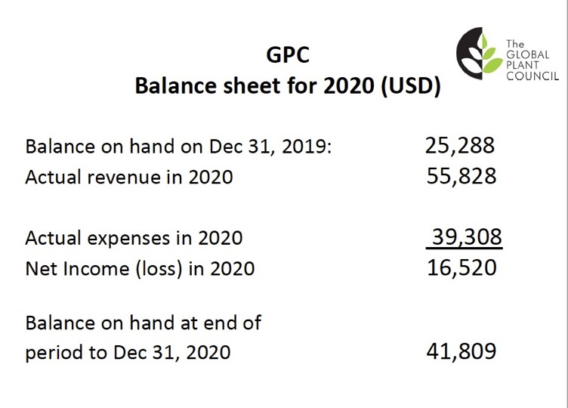

*Prof Ros Gleadow*

*ASPS representative on the GPC*