WSCS – ASPS Council Report 2021
Contents: Social Media, Phytogen, National Science Week and member metric and webpage updates
WSCS team: Janet Wheeler, Georgia Koerber, Beth Loveys, Frances Sussmilch, Caitlin Byrt
ASPS Social Media
In the past year, the ASPS WSCS has continued to make use of our social media platforms to raise the profile of the Society, highlight Australian plant science research and facilitate networking between our members. Since our last annual report, our tweets have been viewed over 295,000 times, and we have had over 39,000 new profile views and gained >750 new followers on Twitter – a 55% increase from 1500 followers last year. We make a concerted effort to find and follow Australian plant scientists, particularly students/ECRs who are not yet members to foster new connections with our Society. In Dec 2020, we started a Twitter list of ASPS members to help us to see and amplify content from our members and to help our members connect with each other. We already have >110 Twitter-active ASPS members included on this list, and encourage members to DM us to be added. We also continue to encourage members to tag @asps_ozplants on Twitter so that we can share content we may have otherwise missed. We retweet ASPS member papers, particularly from students and job opportunities when they are relevant or tagged, with an average of 2 tweets/retweets per day.
The ASPS Facebook page now has over 2100 followers, up 100 from last year.
We hope to continue our growth on these platforms into 2022.
ASPS Phytogen
In the past year, editions of Phytogen have been sent out by the WSCS each month. Again, it felt like a very different year with the COVID19 pandemic continuing. The Twitter, Facebook and emailing out were excellent in helping to get the content out. Reflecting on editions, Phytogen provides a wonderful environment for cataloguing activity of the society, inspiration for students and communication of events.
Throughout the year, editions had content supplied by Peter Ryan (October 2020; incoming president), Dr Beth Loveys, Plant Science Education Representative with example of online delivery of practical content (December 2020), an interview with Peter Ryan (January 2021), and report from Dr Alex Wu (University of Queensland) 2020 Peter Goldacre Award recipient (February 2021). Then, Dr Georgia Koerber (March 2021 – ASPS Environmental and Ecophysiology: Global Change Representative) with an article about upskilling in this pandemic, Peter Ryan explaining science week event planning (April 2021), and members who attended science meets parliament, online event (last week in March 2021), were Diana Ramirez Garces (ANU) and Joseph Pegler (University of Newscastle). In this April 2021 edition was also published an article about Hank Greenway with his passing in February 2021, written by Brian Atwell and many others.
There were also editions with reports from 2020 Jan Anderson Award joint recipients – Dr Crystal Sweetman, Flinders University of South Australia (February 2021) and Dr Kristine Crous, Western Sydney University (June 2021). July and August 2021 featured science week events held nationally, and an open letter from the ASPS executive to the ARC considering pre-prints. September 2021, ASPS 2021 awards were announced and feedback sought for ASPS Diversity and Inclusion Policy with mentimeter poll. Feedback is shown below.
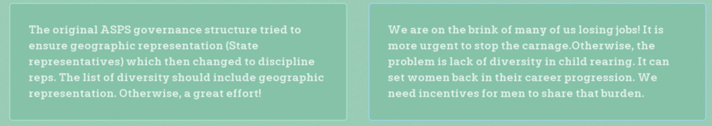
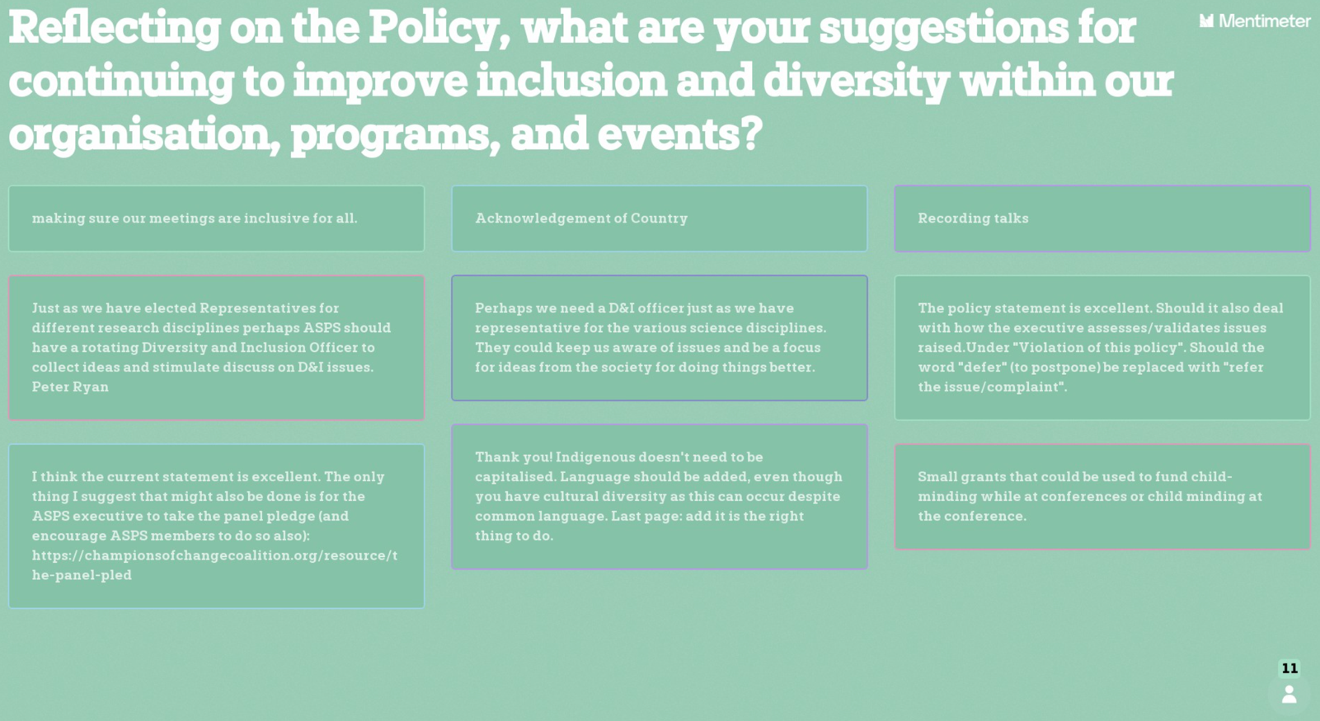

October 2021 was registration for the ASPS Hybrid Conference 2021. As we progress into 2022, contributions will be interesting as we move past the COVID19 pandemic.

National Science Week
We created a YouTube channel (https://www.youtube.com/channel/UC4-hDpe7OR3kwpMxy4ES6ng).
This was particularly focussed on states that were in lockdown at the time that had to cancel live events and included a “Meet a Plant Scientist” video series https://www.youtube.com/playlist?list=PLCjVjret6uSjalUbDCO8a8jjuJesKZ8y3.

The ACT was represented with talks from CSIRO and ANU researchers including our President Dr. Peter Ryan, Jess Hyles, Dr. TJ Higgins AO, Dr. Di He, Prof. Uli Mathesius and Dr. Ricky Milne (https://www.youtube.com/playlist?list=PLCjVjret6uSh67u7d2U2B1mGRFARal9mt). The Byrt Lab at ANU walked us through Agrobacterium transformation using the floral dip method (https://www.youtube.com/watch?v=Hj0iM3zi6_E&list=PLCjVjret6uSg1pLNehyuIm01NTuIQH7PM).

Researchers at Southern Cross University, including Dr. Jay Anderson, Master of Science candidate Janelle Schafer, and Dr Priyakshee Borpatra Gohain, gave talks about their research (https://www.youtube.com/playlist?list=PLCjVjret6uSjLV-oQh-iMEwaixzbn1zLm).

Prof. Ros Gleadow from Monash University talked about her research on how plants including sorghum and cassava make cyanide (https://www.youtube.com/watch?v=6egOt1qNo58&list=PLCjVjret6uSgZYVZ_DhQ8KZq8Vh5NIC9e).

Prof. Tim Brodribb from University of Tasmania showed us why leaves die during drought stress with a video depicting what happens to leaf veins during this process (https://www.youtube.com/watch?v=0M-sZETVoQ8&list=PLCjVjret6uShxXJbRyx1HIJZbEtyS8tK-).

University of Sydney https://youtu.be/6tQi0Wuugxg and University of Queensland ASPS research was also represented.

Janet’s ASPS member metrics and ASPS page views
Current ASPS membership
Membership type | Number of members
Ordinary membership 1 year* | 36
Ordinary membership 2 years* | 59
Ordinary membership 4 years* | 49
Student membership 2 years* | 172
Retired | 15
Life | 7
Corresponding | 12
Honorary (reciprocal Societies) | 1
Sustaining* | 0
Current financial members* | 351

Over the past 60 days ASPS web page top views have been;
Plants in Action 2nd edition | 1541
Membership | 1796
Events page | 2106
Registration page for conference | 2359
ASPS Conference 2021 page | 5064

In the last year we posted 29 jobs on the jobs page.

Draft 2022 ASPS blog post calendar
 | Usual eg GPC, employment | Committee contributions | WCSC contributions | Student contributions | Phytogen related | Secretary
December 2021 | GPC E-bulletin |  |  |  | Congratulations to the organising committee to a fantastic ASPS 2021  Any outstanding winners reports? | Minutes of AGM to send. Action items from Council/AGM. Welcome to new discipline reps and new executive team.
January 2022 | GPC E-bulletin | President’s welcome | Call for Jan Anderson, Peter Goldacre, award application |  | Winner reports (student posters ASPS 2021) | Send reminder for Committee Contribution
February 2022 | GPC E-bulletin | Environmental & Ecophysiology Rep | Call for Teaching and outreach Award application  Welcome to new student reps (hopefully) |  | 2021 Robertson recipient report  Applications for ALL awards close 14th Feb | Send reminder for Committee Contribution
March 2022 | GPC E-bulletin | State report…SA | Science meet parliament report and call for nominees for 2022 SMP |  | Reminder IPMB and ComBio 2022 | Close of 2022 Jan Anderson, Goldacre award  Send reminder for Committee Contribution
April 2022 | GPC E-bulletin | Plant-Microbe Interactions Rep | Remind members end of Earlybird Registration for ASPS meeting/ComBio  Friday 26 June 2022  Abstract Submission Deadline  Friday 26 June 2022 |  | Winner reports (student) | Close of Teaching and outreach award  Send reminder for Committee Contribution
May 2022 | GPC E-bulletin | Whole Plants Rep | Call for student travel grants to IPMB/ComBio  Fascination in Plants Day |  | Call for student travel grants to IPMB/ComBio | Send reminder for Committee Contribution
June 2022 | GPC E-bulletin | State report …NSW | What did you do for Fascination in Plants Day? |  | Early bird registration and abstracts due for ComBio | Send reminder for Committee Contribution
July 2022 | GPC E-bulletin | Plant Development Rep |  |  | Early bird registration and abstracts due for IPMB?
August 2022 | GPC E-bulletin | Secretary AGM docs |  |  | Reminder IPMB/ComBio 2022 | Secretary AGM docs  Minutes of AGM. Action items from Council/AGM. Instructions for ASPS reps on LOC of next ASPS meeting/ComBio. Welcome to new discipline/student reps.  Send reminder for Committee Contribution
September 2022 | GPC E-bulletin | Cell Biology Rep |  |  | ComBio 2022
October 2022 | GPC E-bulletin | Genetics & Molecular Biology Rep |  |  | IPMB
November 2022 | GPC E-bulletin
December 2022 | GPC E-bulletin |  |  |  | Poster and oral student winners  RN Robertson Travelling Fellowship 2022

