This year, I was fortunate to be selected to represent the ASPS at Science Meets Parliament (SMP) in March. This year’s format took a hybrid approach, with initial professional development taking place online, and followed by networking day and a gala dinner in person in Canberra.
Organised by Science & Technology Australia (STA), SMP is an incredibly valuable opportunity to bring scientists from across Australia into direct contact with parliamentarians and their staff. It was also fabulous training in how to communicate our complex research experiences into clear messaging for maximum impact when engaging with policy makers.
There were many highlights, but they included an inspiring interview by Misha Schubert (CEO of STA) of Dr Katalin Karikó, who developed the mRNA technology that underpinned the COVID19 vaccines. Subsequently, Dr Karikó was been awarded the Nobel Prize for Medicine, along with her collaborator Dr. Drew Weiss. Her honest discussion of the challenges she has faced in her career spoke to many, and her passionate resilience in the face of so many hardships was incredibly motivating.
Attendance at Parliament House included an opportunity to meet Senator Brockman and discuss the intersection of agricultural biotechnology, sustainability, and Space, and how it sits at the heart of the newly awarded ARC Centre of Excellence in Plants for Space, on which I am a CI. This was followed by a sparkling gala dinner attended by all members, as well as many parliamentarians, and included Minister for Industry & Science the Hon Ed Husic MP as the plenary speaker (read Minister Ed Husic’s address here).
It was a wonderful opportunity to engage with our policy makers, but it was also wonderful to be in a room full of enthusiastic scientists from all disciplines and all corners of Australia. There was so much to discuss and many new connections were made. I’d highly recommend this experience to anyone!

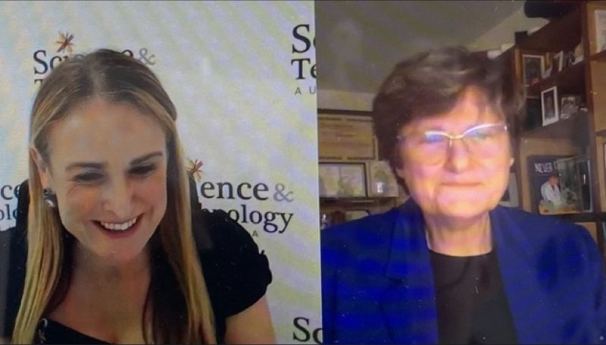
Photo (L-R): Misha Schubert and Katalin Karikó in discussion as part of the SMP online professional development
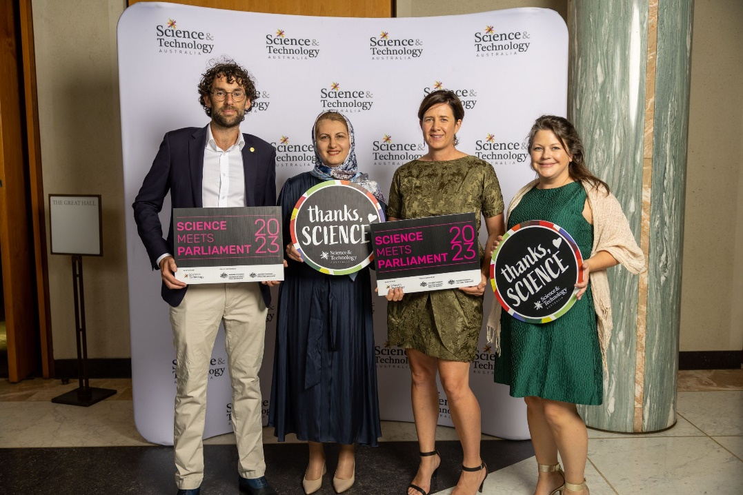
Photo (L-R): University of Adelaide representing at the SMP gala dinner: Matt Knowling, Shervin Kabiri, Tamara Jackson, Jenny Mortimer (ASPS)

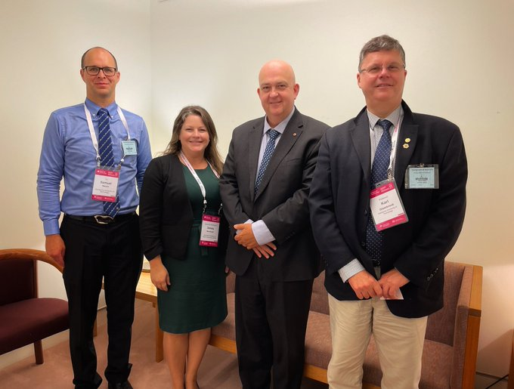
Photo (L-R): Sam Meure (Swinburne), Jenny Mortimer (UoA/ASPS), Senator Brockman and Karl Glazebrook (Swinburne)

