Ensuring Food Security Through Innovative Food Production at Western Sydney University.
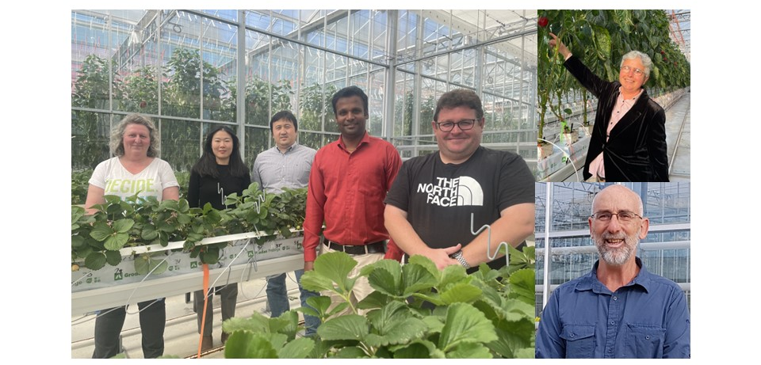
The Team: Robert Sharwood, Michelle Donovan-Mak, Jayakumar Bose, David Randall, Jing He, Oula Ghannoum and Zhonghua Chen.

Image – From Left to Right: Michelle Donovan-Mak, Jing He, Zhonghua Chen, Jayakumar Bose, Robert Sharwood, Oula Ghannoum and David Randall.

Summary:
Our team has created an innovative learning environment tailored to current and future leaders in the horticulture, plant biology, and food science sectors with the long-term vision of providing healthier, and more sustainable, plants and food. In 2017, Western Sydney University and Horticulture Innovation jointly established the National Vegetable Protected Cropping Centre (NVPCC), which is used to train the next generation of growers, food practitioners, plant scientists, corporate leaders and educators. We developed three courses to bridge the protected cropping career pathway gap, Graduate certificate, Graduate diploma, and Master of Science with relevant majors. Industry informed and tailored subjects use innovative pedagogical approaches, including: flexible learning, online learning pods, and live flipped-learning tutorials. Academic materials are presented in multiple forms to engage all VARK learning styles, visual (YouTube, pictorial, graphical) audio (sound clouds, recorded lectures), reading/writing (written documents, checklists, writing tasks), kinaesthetic (hand-on practical in greenhouses, laboratories, entomological field collections).

