Lim Chee Liew, School of Agriculture, Biomedicine and Environment, La Trobe University.
In March 2024, I had the pleasure of representing the Australian Society of Plant Scientists (ASPS) as a delegate to the Science Meets Parliament (SMP), an annual event at the parliament house, Canberra, organised by Science and Technology Australia (STA). This year was the biggest ever event with 360 delegates, 90 Parliamentarians, and more than 50 amazing speakers.
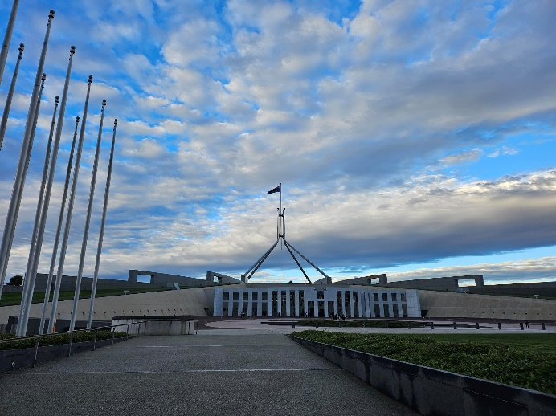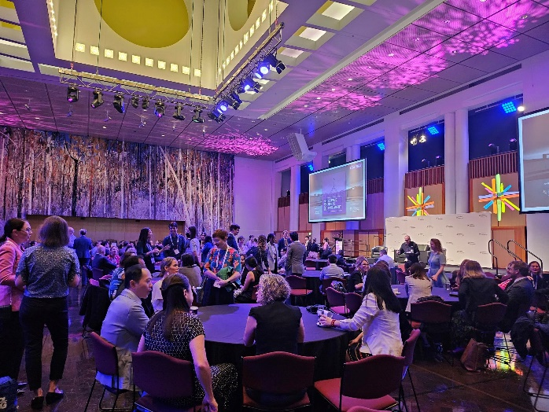
Over the two-day event, I have the opportunities and privileges to hear from leaders and policy maker about how to play an active role in shaping our scientific policies and future. One of the highlights was the incredible speech by Australia’s Chief Scientist Dr Cathy Foley who emphasised the fundamental science is equal to if not more important than translational science because of the social benefits and “be a well and not a waterfall of expertise” to engage effectively with parliamentarians and public as an expert. Minister of industry and science, Ed Husic acknowledged Australian researchers for advancing science, health and tech and announced new STEM funding that supports for collaboration with research institutes in Asia and the passing of Australian Research Council Amendment Bill 2023 in Parliament. On top of these, I was really impressed by the insightful National Press Club addresses from STA president Prof Sharath Sriram which highlighted the need of Australia to boost R&D spending to 3% GDP as a bold investment to create an innovation ecosystem and more job opportunity of high value jobs. “Be a smart country, rather than a lucky one” was my take home message from Prof Sharath Sriram.
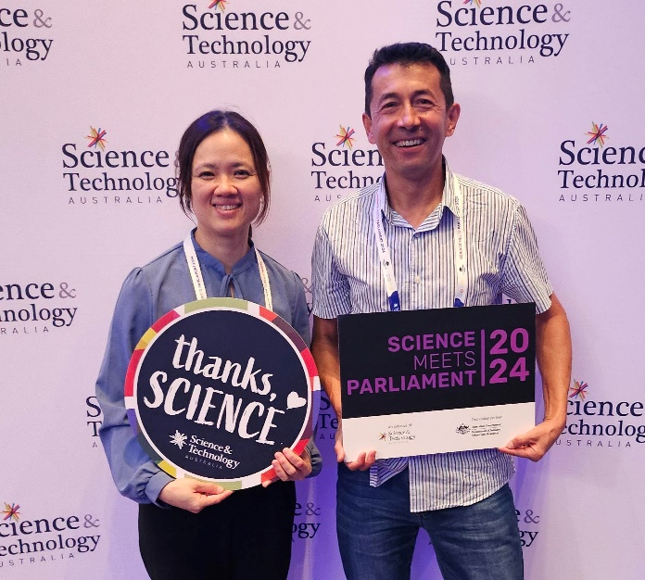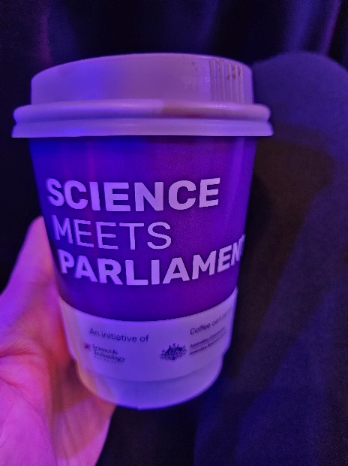
There is more work to be done in order to bridge the gap on what the parliamentarians do and what we scientists know through science communication and engagement. As scientists, we need to be equipped with advanced skills in policy engagement, communications, advocacy, and influence. Feyi Akindoyeni on the panel of advocacy also stressed on communication being persuasion, cut through and relevance, build a relationship and make sure your ask is clear. I have also increased my understanding about how scientists can engage with the media from media representatives and science communicators Brandon How, Donna Lu, and Nate Byrne. CEO of CSIRO, Doug Hilton highlighted the importance of collaboration by using metaphor of “just like food, science is much better, and far more enjoyable, when shared”.
On top of the excellent seminars and talks, the Gala Dinner at the Great Hall, Parliament House was the networking highlight of the SMP. I got my opportunities to engage with scientists and parliamentarians from different area of expertise. Attending Question Time was another highlight for me where I get to watch Parliament in action in person.
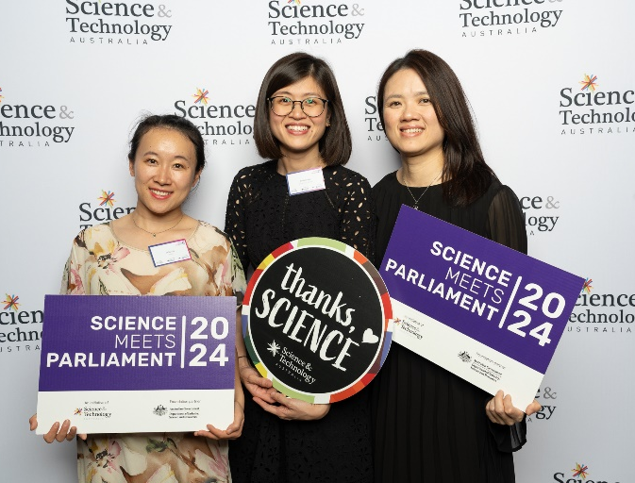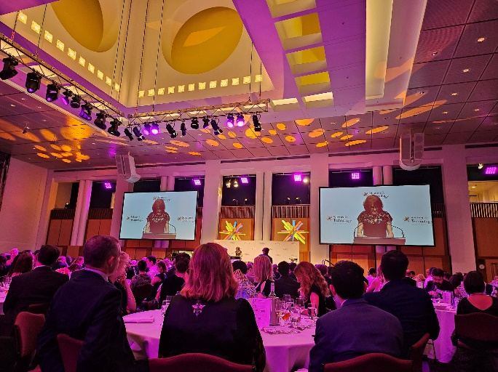
It was a great honour to represent ASPS to attend SMP2024. It was a great fun and eye-opening event! It provided me an excellent opportunity to learn about communicating and engaging with policy makers and also to network with scientists from diverse area of STEM.

