**Meets Parliament 2023 report**

Dr. Neeta Lohani, Associate Research Fellow in Agriculture & Plant Science, Food Sciences, Western Sydney University, Richmond, NSW, Australia.

Current Affiliation: Postdoctoral Research Associate, Donald Danforth Plant Science Center, St. Louis, Missouri, USA.

As a scientist interested in the intersection of science and policy, I was compelled to participate in the Science Meets Parliament (SMP) event. This annual gathering fosters discussions between scientists and policymakers on the role of science in shaping Australia's future. I attended as a delegate representing the Australian Society of Plant Scientists (ASPS), which also sponsored my participation. The event was immensely beneficial, enhancing my advocacy skills, fostering relationships with policymakers, and facilitating interactions with fellow scientists and researchers.

Before the main event in Canberra, I took part in a 3-day virtual program featuring keynote speeches and panel discussions with distinguished scientists, politicians, and policy experts. This preparatory program provided insights into the policy landscape and honed our communication skills. A notable highlight was the presentation by UCLA Professor Terence Tao, regarded as the world’s foremost living mathematician and the 2022 Global Australian of the Year.

The day at Parliament was filled with various activities, starting with a session led by Dr. Cathy Foley, Australia's Chief Scientist, and Nobel laureate Brian Schmidt. They discussed their experiences in science and its critical role in addressing complex challenges and shaping the future. This was followed by a panel emphasizing the need for collaboration between the scientific community and industry in Australia. I also participated in the parliamentary question time, an enlightening experience. Later that evening, we attended the national gala dinner, which provided a fantastic opportunity to network with prominent scientists and parliamentarians. The dinner included speeches from key government figures such as Richard Marles (Deputy Prime Minister), Ed Husic (Minister for Industry & Science), and Karen Andrews (Shadow Home Minister). A statement by The Hon Ed Husic MP struck a chord with me: “Science isn’t a ‘nice to have’ only when times are good. It is essential to the prosperity of this country, to our national wellbeing, and to a modern economy.” For me, the gala's highlight was Paul Girriwah House's didgeridoo performance.

Attending SMP was incredibly valuable for me as both a scientist and an advocate. I am deeply grateful to ASPS and would encourage all researchers to participate in this event, as it provides a crucial platform for engaging with policymakers, underscoring the significance of our scientific endeavours, and fostering collaborations that support evidence-based decision-making.

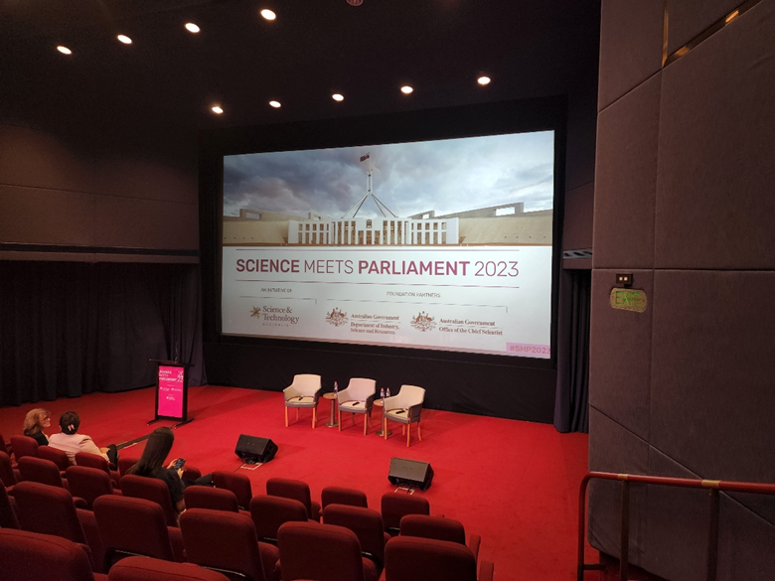

First day and opening event of SMP in person 2023.

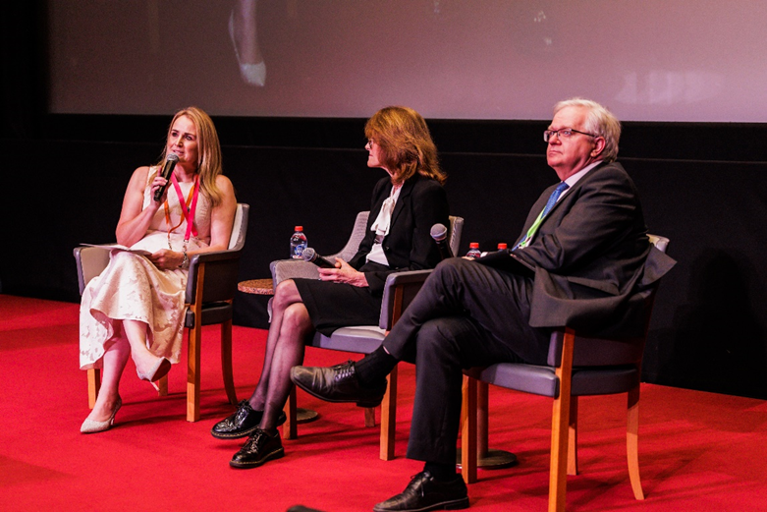

From left to right: Misha Schubert (CEO, Science & Technology Australia), Dr. Cathy Foley (Australia’s Chief Scientist), Nobel Laureate Brian Schmidt (Distinguished Professor and Vice-chancellor of the Australian National University).

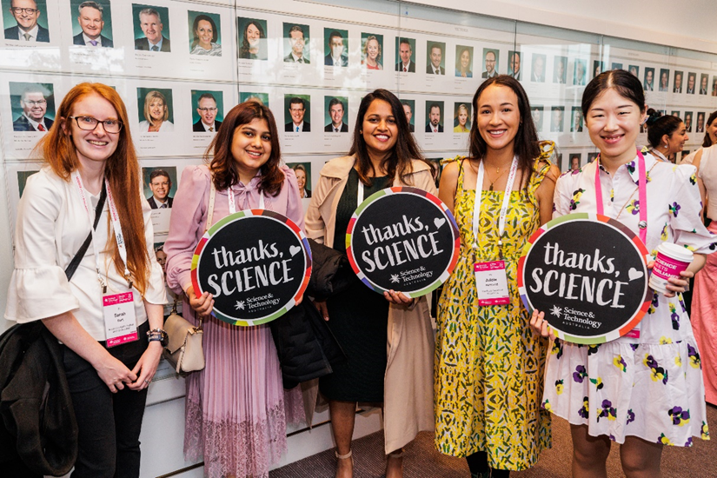

Dr. Neeta Lohani (in the center) with other women delegates at the SMP, 2023

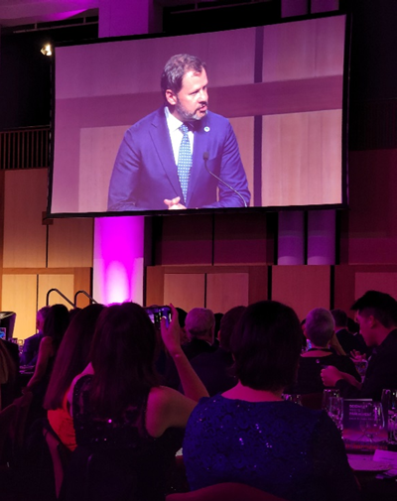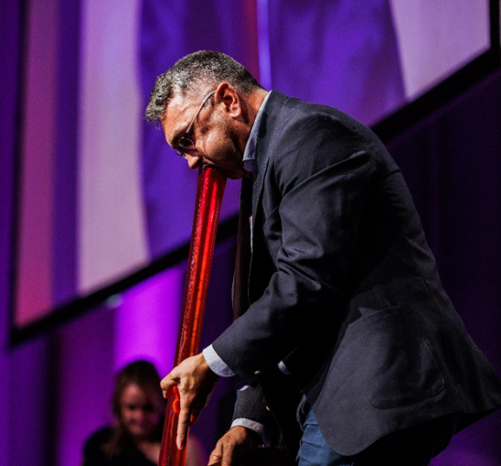

Minister for Industry & Science, The Hon Ed Husic MP and Paul Girriwah House, Ngambri Elder playing the Didgeridoo.